**Humanistic Constitution**

In addition, the right understanding also provides us the basis for a humanistic constitution which is essential to the development of an unfragmented human society and a universal human order. Working towards the comprehensive human goal and developing the competence for ethical human conduct will be among the salient directive principles of a humanistic constitution. It will also be conducive to social justice.

Presently, the human society is divided into various castes, creeds, religions and nationalities whose objectives and interests are proving contrary to those of others. Accordingly, a major part of human endeavour is used in handling these conflicts and contradictions; paradoxically, the human beings are spending a substantial part of their energies and resources in preparing themselves for destructive purposes. As we can now understand, when the parameters of human welfare are universal, i.e., commonly applicable to all human beings, why should the human endeavour in pursuit of these common objectives be conflicting to the interests of each other! This can only be there because of our ignorance, because of our incorrect assumptions/ beliefs of our happiness and of the reality as the whole. Presently, our efforts are directed largely towards using various modes of enticements and punishments to change the behaviour pattern of people. However, it is not successful in the long run. Things can only be set right by developing human consciousness, by developing right understanding among people and in no other way. Thus, the right understanding also offers a satisfactory and spontaneous resolution of the prevailing human conflicts ranging from the family level and going up to the global level.

It may be a thought-provoking exercise to visualise a model of humanistic constitution. In the light of the right understanding:

• What will the fundamental rights and duties be?

• What will the way be to ensure justice and protection in the society?

• What will be the format of working for a universal human order?

• How will people connect to the world family?

• How will the representation of people be ensured in maintaining order in the society?

These and all such issues are to be addressed. To begin with, the family will be smallest unit of order in the society. Moving from family to the world family, the constitution will provide the basis of harmonious living. These are relevant issues in terms of visualizing the holistic way of life in the present scenario

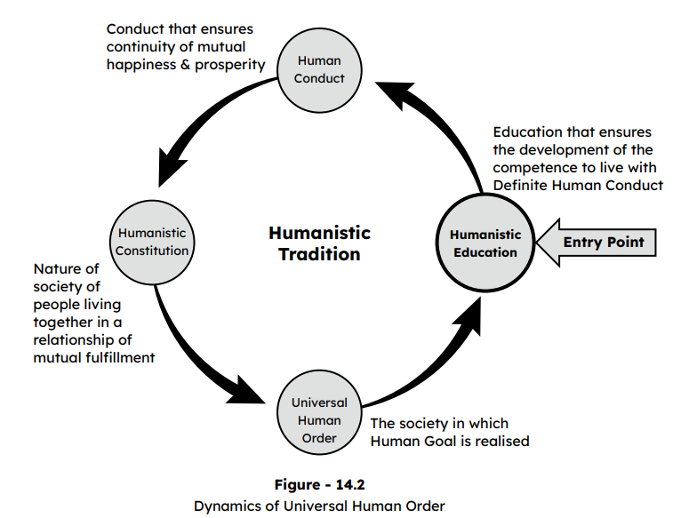

As mentioned in fig. 14-2, you can see that the education in any society is the one which primarily develops the perspective and sanskar at the individual level. This individual sanskar reinforces the collective sanskar or culture in the family and in the society. This culture expresses itself as the civilisation which reinforces the individual sanskar through education. If we want a harmonious, peaceful civilisation, it has to start with the individual. This is possible and that is what we are trying to say that education is going to be the agent for this transformation. Humanistic education leads to human conduct, human constitution, universal human order and in turn, universal human order ensures humanistic education for the next generation. That is how the whole tradition would look like if it has to be humanistic tradition. If all these has to be ensured, where do we start?

Evidently, humanistic education is the entry point. That is why we are trying to draw your attention from all directions, that we, as educationalists, as teachers, as education administrators and as policy makers, are responsible to bring about this transformation. We have to be the most active agents to start this transformation. Humanistic education is the entry point. Once this wheel starts rolling, it would bring about a continuing humanistic tradition, that would be able to ensure the fulfilment of human goal for every human being, generation after generation. That is what human society aspires for. So finally, it may be concluded that it is possible to move towards a universal human order with the help of suitable systems and policies evolved in the light of right understanding. Such a development will be naturally acceptable to all human beings. The whole existence except the human beings is already operating in harmony. It is for us, the human beings, to understand, to appreciate this harmony and to play our role in this total order (harmony).

**Salient Points**

• The right understanding helps us identify the comprehensive human goal, i.e., right understanding and right feeling (happiness), prosperity, fearlessness (trust) and co-existence (mutual fulfilment).

• This gives us the vision of the holistic way of life in all the dimensions of human living.

• The understanding of harmony gives the basis and framework of humanistic education and constitution. • The universal human order in terms of the various dimensions and different steps of order (from family order to world family order) in the society can be visualised on this basis.

**Universal Human Order**

**The Core Message**

The core message of this course may be summarised as follows: To be able to fulfil the basic human aspirations i.e., happiness and prosperity and their continuity, it is essential to gain the right understanding – the understanding about oneself vis-a-vis the rest of existence, the understanding about continuous happiness and prosperity. This involves the realisation that there is an innate harmony at all levels of existence. In fact, the whole existence is co-existence. It is the essential purpose of human beings to understand this harmony and co-existence and learn to live in accordance with it and be fulfilled. This truth has been grossly ignored in our present world-view whereby happiness and prosperity are perceived primarily in terms of maximisation of sensory enjoyments, maximisation of wealth and accumulation of more and more physical facility. This misperception is leading to serious problems in all walks of life and is not conducive to sustainable happiness and prosperity. Hence, it becomes imperative to change this world-view, to change from ‘animal consciousness’ to ‘human consciousness’. Guided by the right understanding, the values in relationships can also be properly understood and fulfilled. Also, in the light of right un derstanding, the life styles can be appropriately designed and the need for physical facility can be appropriately assessed. Further, guided by the right understanding, suitable methods of production can be adopted to fulfil these needs in a people-friendly and eco-friendly manner. Appropriate value education inputs to facilitate the process of self-exploration are essential to initiate this transformation towards human consciousness at a mass scale.

In this course, a preliminary outline of the framework of right understanding has been presented. An attempt has also been made to initiate the process of self-exploration to move towards right understanding.

In fact, it is naturally acceptable for every human being to live with human consciousness, this is their holistic development. It leads to:

• Individual transformation – from animal consciousness to human consciousness and

• Societal transformation – from inhuman society to humane society.

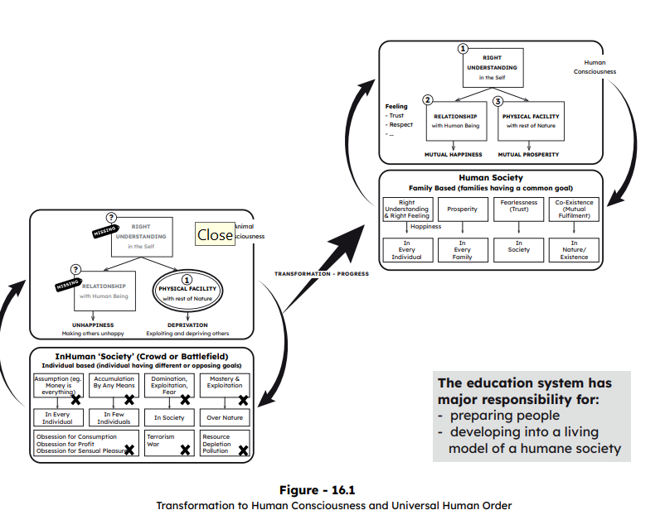

Having obtained a brief exposure to the universal basis of values and ethical human conduct and its implications in life and profession, let us now conclude this course by indicating a few tangible steps that the human beings can take to begin this important journey towards a holistic way of life.

**Appreciating the Need for Self-exploration**

The first and foremost step to begin this journey is to be adequately convinced about the need for carrying out self-exploration. The need for seriously analysing ‘what we presently are’ and ‘what we really want to be’, the need to verify our beliefs and pre-conditionings, the need to understand what is motivating our actions presently and what its consequences are - has to be duly appreciated so that we may be able to put in the required effort and give due priority to make the transition possible. When through self-exploration, we are able to see a big chasm between what .we really want and what we are presently pursuing, the urgency of taking the corrective steps becomes clear. Getting ready for self-exploration is thus a vital step towards transition to the holistic way of life. Today, we are mostly motivated by what other people around seem to be doing and their attractive consequences in the immediate future. Whatever seems to be more pleasant to our sensory experience appeals to us as worth pursuing. Thus, in spite of increasing problems all around, we do not get motivated enough to seek a viable alternative because of our strong pre-conditioning and sensory attraction. In fact, we tend to find superficial justification to defend our present world-view and thereby carry on with the status quo. The whole training towards right understanding seems to be largely missing from our present education system. Thus, the need realisation is the first trigger to transition.

**Facilitating the Understanding of Harmony at Various Levels**

Having realised the need adequately, the next important step is to have access to the ways and means to facilitate the process of self-exploration towards right understanding. This implies that we need to have a proper framework of understanding so that we can discover the harmony at various levels starting from our own-self and spanning up to the entire nature/ existence as discussed in this course. In order to facilitate this journey, it is important to make available appropriate content and methodology as well as the necessary wherewithal for Value Education which can effectively enable the process of transformation.

Appropriate inputs in value education need to be made an integral part of all our education – both formal as well as informal. This needs a largescale effort to develop a rational and universally acceptable content and methodology for value education, preparation of appropriate resource material and adequate training of teachers to carry out this task effectively and at a large scale.

**Step 1: Steps for Individual Transformation**

The change of ethos involves a long-drawn effort for transformation at the personal level (see fig 16-2). It essentially means understanding the existential harmony at all four levels (individual, family, society, nature/ existence) and then living in harmony at each of the four levels. This involves three important sub-steps.

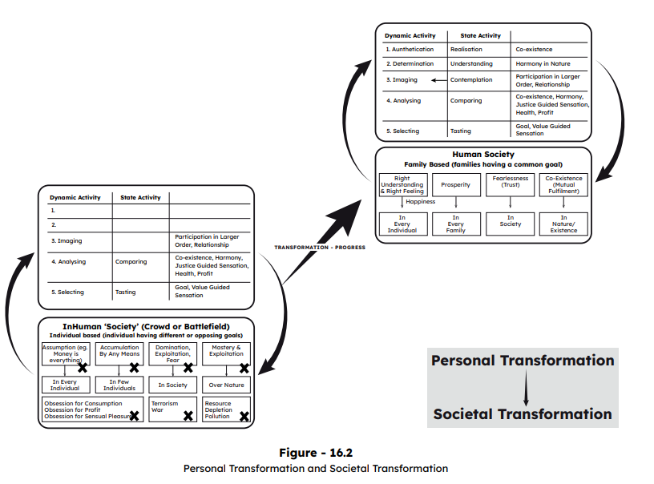

These three sub-steps are:

1. To verify the proposals (particularly those given in chapters 5-11) on your own right, i.e., on the basis of your natural acceptance and on the basis of your experiential validation. The outcome of this is right understanding (understanding the harmony) as well as right feeling (the feeling of harmony) and right thought (the thought of how-to live-in harmony). The behaviour, work and participation in larger order will then be guided by the understanding of harmony .
2. To be aware of yourself, of your imagination (desire, thought and expectation) every moment. With this awareness, you will know the content of your imagination and also of all the accumulated acceptances which are your sanskar (recall from chapter 6). Since these acceptances have accumulated over a long period of time, your sanskar has developed with or even without your awareness.
3. Now, with the awareness of your imagination, of your sanskar, sub-step is self-evaluation – to evaluate your sanskar vis-à-vis your natural acceptance. Start this step when you feel comfortable with the first two steps, and not before that. Identify the root desire behind each imagination. The desire is in the form of feeling / purpose. Find out if that feeling is naturally acceptable or not, if that purpose matches with your natural purpose / human values or not. If it is in line with these, that sanskar will lead to harmony and therefore, happiness, otherwise it will lead to disharmony, contradiction and therefore, unhappiness. The self-evaluation will help to purify your sanskar. The sanskar that is in line with your natural acceptance will be reinforced, while that which is not in line with your natural acceptance will become weak and eventually drop. In this way, your new sanskar will be more in harmony with your natural acceptance than your previous sanskar. [recall that sanskar (t) + environment (t) + self-exploration (t) + sanskar (t+1)]

**Step 2: Creating Mass Awareness towards Holistic Development**

With the right understanding and right feeling in you, you will develop the willingness and capacity to share with others. This is natural – you can see if you come to know something useful, you naturally want to share it! Sharing is the logical next step. Now, you are facilitating and developing other people to have the right understanding, right feeling and right thought.

It involves dialogue and discussion with a view to facilitate self-exploration in the other. It can be in the form of informal talks and formal workshops. The people to share with would include:

* **Family members and friends:** This will enhance the harmony in the family and enable you to participate more freely in the larger order. The family and friends may also contribute their time, effort and resources for it.
* **People who have interest and readiness for purposeful social effort and social development**: There are many people who want to make effort for the betterment of the society. Through the sharing, and enhancement of their perspective they will be able to do what they are doing in an even more effective manner.
* **Educators, teacher and education administrators**: Once they can see the possibilities, they will invest themselves to introduce human values in education, they will be able to refine the content and process of education and provide the education with even more responsibility.
* **People connected to governance**: they will be able to introduce it in the policy level.
* **Your colleagues at work**: It can be a part of the learning activities at your workplace.

**Step 3: Moving towards Humanising the Mainstream Education**

As the awareness amongst the people grows, the main task is to gradually move towards humanistic education which could involve the following sub-steps:

1. Integrating appropriate inputs of value education at various levels in the current curricula from school education to higher education.. This process naturally starts with the introduction of a foundation course (such as the one being proposed in this book). This should be backed up by introducing new elective courses like:

— Understanding the human being

* Understanding co-existence in existence

— Human relationships, values and ethical human conduct

— Universal human order

— Technologies and systems for holistic development

— Management by relationship

2. To effectively proliferate the above effort, requisite support and policy initiatives by monitoring agencies, such as MHRD, UGC, AICTE, ICMR, University Academic Councils and School Education Boards will be helpful.

3. Further, it will be essential to introduce teacher orientation programs (faculty development programs) and development of resource material to implement the above suggestions at a large scale. This can be actualised by establishing Human Values Resource Centres at the regional and national (international) levels.

4. The next sub-step will be to provide adequate thrust to R&D dedicated towards transforming the whole mainstream education into humanistic education (value-based education). This is going to be a long-drawn process. However, it is indispensable.

**Step 4: Developing Models for Holistic Living in Educational Institutions and in the Community**

This will also necessitate linking the educational institutions with local development programs in collaboration with voluntary organisations and government agencies. Accordingly, the focus of R&D in higher education institutions will need to be shifted towards various aspects of holistic development, resulting in the development of real-life models facilitating universal human order.

**Concluding Remarks**

To conclude, let us see whether we are sufficiently clear about the following proposal:

**To ensure happiness and prosperity and their continuity for all human beings, the transition to human consciousness and humane society is essential.**

This requires a dedicated effort to implement at a mass scale, the humanistic education focusing on right understanding. It can be initiated by introduction of appropriate value education inputs in the present curricula.

The urgency of this task has to be adequately realised and accordingly efforts are to be made commensurate with the need. The evolution at the personal level has to be given priority. Further, efforts are also to be directed towards evolving models for holistic development, appropriate policies, programs and systems. Now, it is a great opportunity for all of us to join hands to become an active participant in this potential transformation!